Sample Human Rights Management Standard

SCOPE
The requirements of this Management Standard shall apply worldwide to [Company Name] and its subsidiaries, affiliates, partnerships, ventures and other business associations that are effectively controlled by [Company Name], directly or indirectly (together the "Company"), and all directors, officers and employees of the Company. It covers operations at all phases of development, from pre-exploration to post-closure.to all [Company Name] owned, managed, and [Company Name] leased locations worldwide, and includes mining, refining, smelting, associated infrastructure and adjacent farm/buffer lands. At locations where [Company Name] does not have a controlling interest, [Company Name] shall encourage compliance with this document.

PURPOSE
The purpose of the Standard is to give effect to the [Company Name] Human Rights Policy, which requires all [Company Name] Locations to identify, prevent, mitigate, and report on any actual or potential human rights impacts that [Company Name] causes, contributes to or is linked to. The Standard sets out the requirements for effective identification, management, and remediation, of actual and/or potential human rights impacts, identified through due diligence and or through grievance mechanisms, associated with [Company Name]’s operations and business relationships.

BACKGROUND
In the United Nations Guiding Principles for Business and Human Rights (UNGPs), Human Rights Due Diligence (HRDD) is understood as an ongoing management process for the identification, prevention, mitigation, and remediation of potential and actual human rights impacts, associated with [Company Name]’s activities. An expanding array of jurisdictions have codified the expectations of the UNGPs into binding law, including where [Company Name] operates or has business relationships. These laws obligate [Company Name] to conduct HRDD and report on findings and progress.
This management standard sets out the ways in which [Company Name] resource functions, locations and corporate offices shall integrate human rights considerations into existing management practices and mechanisms.
[Company Name]’s management of human rights is built on the Plan, Do, Check, Act (PDCA) framework, which also underpins [Company Name]’s approach to Environment, Health and Safety (EHS) and Social Performance (SP) management (Figure1).
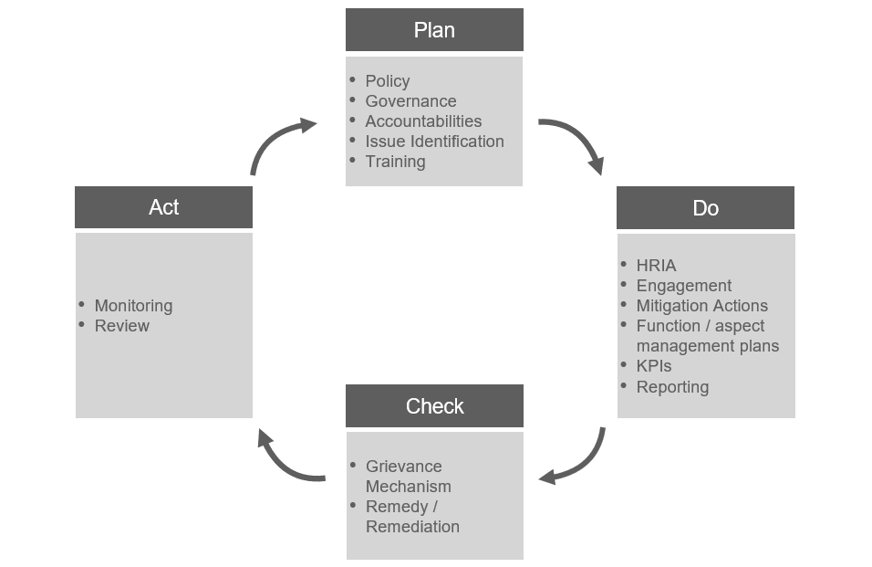
Figure 1. Human Rights Plan, Do, Check, Act (PDCA) Framework

REQUIREMENTS –ELEMENTS OF HUMAN RIGHTS DUE DILIGENCE

Human Rights Due Diligence (HRDD) Overview
HRDD is undertaken in phases, characterized by engagement with affected stakeholders throughout the process. These phases, developed to align with standard industry practice and the expectations laid out in the UN Guiding Principles and emerging regulatory frameworks, include Screening for higher-risk operations; Risk Identification and Assessment to establish the level of due diligence required; Risk-Based Due Diligence conducted in direct collaboration with operations and affected populations; Issue Management; Grievance Management; Impact Mitigation and Remediation; and Periodic Updating and Reassessment to assure that our findings and management approaches to human rights risks and impacts remain current.

Screening
[Company Name] operations shall be screened for human rights risks, based on operating context and operation type/size. The aim of screening is to establish the level of due diligence needed at each of [Company Name]’s global sites.
Human rights contexts can be screened using internationally applicable tools including free screening tools from NomoGaia or paid tools from providers such as ControlRisk and MapleCroft. These tools derive rankings and scorings from globally available indices for civil, political, economic, social, cultural, labor, and conflict conditions. Labor protections are rated by the International Trade Union Confederation. WalkFree tracks modern slavery and forced labor risk. The World Bank charts global governance indicators. Additional tools track corruption (Transparency International), and state-sponsored repression (Political Terror Scale) and state protections for economic rights (Human Development Index). Conflict can be screened using indices produced by the Heidelberg Institute for International Conflict Research.
- Low – Country context has low or moderate scores across the indicators described above
- Mid – Country has moderate levels of human rights risk in the categories above and potentially one high score
- High – Country scores as high risk for two or more categories of rights risk across the indices described above
Operational classifications for heightened due diligence are based on the size and environmental impact of the operational footprint, size of and proximity to neighboring populations, and size of workforce (including contractors). Operations are ranked high- mid- or low- risk.
Site Classification:
- Low – meets two or more conditions: has fewer than 10 workers, 5 or fewer neighbors within 2 mi (3 km), emissions that require no specific permits (e.g. corporate offices), and/or a footprint smaller than 100,000 ft² (10,000 m²).
- Mid – meets two or more conditions while operating (or one or more if closed): operation has 10-50 workers, 100 or fewer neighbors within 2 mi (3 km), and/or a footprint 100,000 - 15,000,000 ft² (10,000 - 1,500,000 m²)
- High – meets two or more conditions while operating (or one or more if closed): operation has over 50 workers, over 100 neighbors within 2 mi (3 km), and/or a footprint larger than 15,000,000 ft² (1,500,000 m²). Site classification is also rated as ‘high’ if it rates as a high-priority biodiversity site under Ecosystem Services analysis.
Classification combining a site-level and a contextual classification, will determine the frequency with which human rights risk and impact assessment will be undertaken.

 |  | Site Classification
 |  | Low | Mid | High
Contextual Class. | Low | 1 | 2 | 3
Contextual Class. | Mid | 2 | 4 | 6
Contextual Class. | High | 3 | 6 | 9

 | Frequency of human rights assessment | Desktop Risk Review | Field-based assessment
1 | Every ten years or in the event of major change | X | Only if risks are identified in desktop
2 | Every 7 years or in the event of major change | X | Only if risks are identified in desktop
3-4 | Every 5 years or in the event of major change | X | x
5 | Every 3 years or in the event of major change | x | x
9 | Every 2 years or in the event of major change | x | x

Risk Identification and Assessment
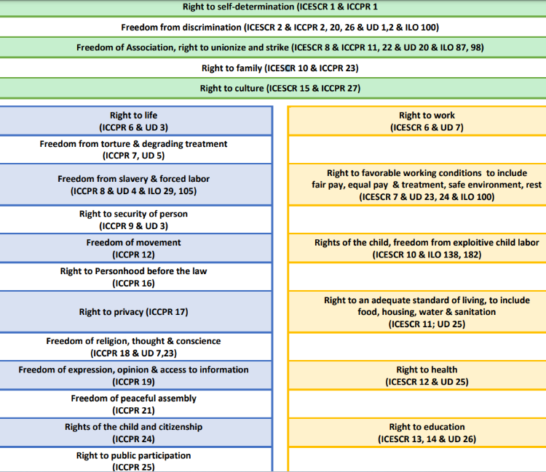
Desk-based risk review entails consideration of both internal and external documentation. A preliminary review of contextual and operational conditions should be undertaken to verify that risk levels previously defined remain applicable. If operational expansion or contextual degradation has occurred, risk review may trigger field-based impact assessment (see below) and result in modifications to the footprint’s schedule for human rights review.
Both interviews and document review contribute to desk-based risk assessment. Key internal dimensions to review for human rights risk assessment are pertinent to environmental, labor & employment, OHS, occupational hygiene, security, and supply chain incidents and management. Key external dimensions for review include shifting civil and political conditions, including corruption risk and conflict, evolving conditions for neighboring industry (e.g. increasing stress on resources or environmental hygiene), and changes in regulatory regimes.
Not all human rights risks identified during Figure 2 Human Rights enumerated in key international instruments
desktop risk review will trigger field-based assessment. In particular, potential violations of the [Company Name] Code of Conduct and Ethics (e.g. identification of discriminatory promotion practices in an office setting) will be reported as an Ethics & Compliance concern. Some risks flagged in risk review can be evaluated and downgraded through further desk review, which is undertaken before field-based impact assessment is commenced.

Risk-Based Due Diligence - Impact Assessment
Human Rights Impact Assessment (HRIA) is undertaken to deepen [Company Name]’s understanding of human rights risks, validating (or invalidating) prior (e.g. desk-based) findings and expanding the scope of review to the full suite of human rights, beyond the highest-severity concerns. It is carried out to benchmark conditions at [Company Name] operations against core human rights instruments enumerated by the United Nations and International Labour Organization.
Human rights instruments outline an array of rights that are broadly categorized pertinent to economic, social, cultural, civil, political, security, labor, and Indigenous rights. [Company Name] cross-evaluates these rights against concrete indicators. Cultural impacts may also emerge from the physical impacts.
Use of data and frameworks is iterative and it results in a matrix of indicators and scores that link real-world conditions to human rights enumerated in international instruments. Document review is undertaken to:
- Map rightsholders in terms of discrimination/empowerment
- Map rightsholders geographically
- Understand local populations through various perspectives e.g. news stories, advocacy reports, Dept of State publications, public census data
- Facilitate the drafting of discussion guides
Stakeholder and rightsholder engagement are used to triangulate information provided by internal and external documentation. External (rightsholder and stakeholder) interviews are undertaken to triangulate:
- Non-technical lines of questioning to triangulate with other data sources
- Group or individual interviews depending on vulnerabilities and trust constraints
- Conducted on rightsholders’ “home turf” to enable direct observation and to assure safe spaces for open communication
(Internal) Personnel interviews and site visit for direct observation enable triangulation across:
- Operations, Environment, H&S, Security, HR, Procurement (always)
- Maintenance, site services, labor leadership (almost always)
- Women, contractor workers (semi-structured, in informal settings)

Issue Management and Prevention
The aim of risk and impact assessment is to proactively identify risks and impacts. When risks are identified, they must be prevented and/or managed. When impacts are identified, they must be mitigated and/or remediated (see section 5.7, below). Human rights issues that are ongoing may require both risk management (to establish controls that prevent future incidents) and impact mitigation/remediation (to actively address the incidents as they occur). After being identified through human rights risk and impact assessment, human rights risk management and prevention is undertaken through operational and enterprise risk management process (ORM and ERM). See [Company Name]’s Risk Management Standard. While locations are responsible for managing risks and issues, corporate leadership is obligated to support in this effort and drive recommendations across multiple functions including operations, human resources, security and others, as detailed below under “Responsibilities and Harmonization with Other Functions.”
Where risks are outside of [Company Name]’s direct control, such as in contractor workforces or in the activities of business partners, risks are prevented and managed through contractual conditions and [Company Name]’s Responsible Sourcing Program, which includes site-based field audit. All workers on site are to be trained on safe practices on site, including labor protections, health & safety controls, and grievance channels.
The Board is accountable for human rights risks and will request updates on challenges and progress in human rights management at regularly scheduled meetings.

Grievance Management and Monitoring
[Company Name] has a multi-layered grievance approach, integrating its company-wide Ethics & Compliance hotline with operational-level grievance mechanisms rolled out site-by-site and coordinated through our Social Performance Function. Human rights grievances can be brought through the Integrity Line, operational-level grievance mechanism, third-party systems through [Company Name]’s voluntary associations (e.g. multistakeholder initiatives and certification bodies), Investor queries, or in direct engagement between [Company Name] personnel and affected people or their representatives.

Impact Mitigation and Remediation
Adverse human rights impacts identified through human rights impact and risk assessment protocols at the operational and/or supplier level or through grievance processes must be mitigated and/or remediated according to their severity. Impact severity is determined based on the intensity and extent of the effect. Intensity is defined as the degree to which an impact will alter a single life. Extent is defined as the breadth of the impact across the population group likely to be affected.
Mitigation and remediation for risks and impacts are established in collaboration with affected rightsholders. Mitigation and remediation of harms may involve proactive initiatives to compensate for or reverse impacts (e.g. through direct compensation or truth & reconciliation efforts), as well as modifications to operations, asset management, site maintenance, human resources approaches, environmental management, health & safety protocols and other site-level functions.

Periodic Updating and Reassessment (risk-based by site; and revision of Salient Issues)
As indicated in section 5.2, above, a timeline is established for reassessment of operational-level human rights risk based on contextual and operational conditions. Because reassessments will document the successful mitigation, management and remediation of some issues while identifying new and unaddressed risks, salient issues will change over time. [Company Name] will publish its salient human rights risks annually in Corporate Social Reporting Directive filings and will update the list through review of human rights due diligence every three years.

RESPONSIBILITIES AND HARMONIZATION WITH OTHER FUNCTIONS
To manage human rights risks company-wide, information needs to be driven upward, mandates need to be driven downward, and training needs to roll out across the enterprise.

The Board carries out oversight. This includes audit, oversight, and follow-up on challenging issues

Corporate functions carry out the following responsibilities:

The Human Rights Team oversees HRDD, engages with site personnel to help develop action plans and supports working groups to manage issues. It coordinates corporate-level support to assure cross-functional information sharing at the corporate manager and director level; Sustainability Team members coordinate with External Reporting and Due Diligence Working Groups to report on human rights risks, impacts and management at the local, regional and global levels.

Social Performance personnel help develop engagement tools and roll out grievance and complaint systems (in collaboration with Human Rights Team), supports with expertise on key challenges with affected communities including resettlement/displacement, livelihood restoration, benefit sharing; Social Performance teams also manage community relations and conduct Meaningful Stakeholder Engagement with Vulnerable Populations.

Biodiversity and Climate Teams help link environmental conditions with users of ecosystem services, including through long-term planning around cumulative effects of climate change and biodiversity impacts.

Legal and Procurement Teams produce contract templates inclusive of responsibilities towards human rights, transparency clauses entitling [Company Name] to audit the conditions of workers and working/living spaces, support clauses entitling [Company Name] to contribute to remediation where gaps are identified, and consequence matrices for nonconformances that are unresolved over a designated period

Ethics & Compliance support with Human Resources on training

VPs escalate site-level human rights issues to regional and global levels

EVPs drive agendas to enable respect for human rights across [Company Name]’s global operations

Site-level personnel carry out the following responsibilities:

External Relations supports implementation of the Human Rights Policy including hosting site-based fieldwork for human rights due diligence. Community Relations functions within External Relations conduct Meaningful Stakeholder Engagement; field, log and manage grievance; and lead cross-functional collaboration on conditions concerning populations outside the fence.

Procurement supports Supplier Site Collaborations, validates the terms and conditions to assure that transparency is built into contracts and a consequence matrix lays out violations of labor rights and other human rights

Plant managers, operations managers, and asset managers review preliminary findings and coordinate management of response plans, including convening working groups and assuring that resources are allocated). Plant managers own remediation and prevention, but lacking the capacity they shall call on corporate-level teams and other functions to support

Contract Managers (1) verify their roles managing contractors flagged for concern; (2) interface with contractor companies for acquiring information pertinent to personnel, hours, wages, HSE protections, adherence to contractual commitments, and assurance of transparency

EHS officers contribute to data-gathering and gap-identification and provide inputs into action plans. EHS officers work with the Sustainability Team to drive compliance with internal EHS protocols

HR managers contribute to data-gathering and gap-identification and provide inputs into action plans. They also assure (and document) that training happens for everyone on site. They negotiate collective bargaining agreements, align operations with labor rights (including adequate wages, reasonable hours, freedom to collectively bargain and strike). Their protocols prevent the use of child labor, forced labor and other forms of modern slavery. HR also assures nondiscrimination and non-harassment (e.g. through [Company Name]’s Harassment and Bullying Free Workplace Policy), with support from global HR functions, E&C, Legal and other corporate functions

Security teams monitor facility entries and departures for the safety of workers and prevention of criminal activity on site; manage compliance with the Voluntary Principles on Security and Human Rights and support the implementation of internal security policies and standards

Cross-functional human rights issue management

Land Management is overseen sequentially by appropriate site-level experts, supported by the Sustainability Team throughout the process. GIS, Government Relations, Community Relations, Environment, Legal, Security and Land Rehabilitation teams may each take a leadership role in managing land acquisition and return. The multiplicity of functions is important because of the various ways land use intersects with [Company Name]’s operations. Indigenous populations are assured the right to Free, Prior and Informed Consent, which is under the purview of Community Relations. Displacement studies are will be undertaken whenever physical or economic resettlement is required. Land encroachment poses security risks which should be managed by the Security team in collaboration with relevant authorities. Permitting and Contracts are, likewise, managed by the appropriate authorities within [Company Name] engaging with relevant state agencies. Rehabilitation is undertaken in the interests of affected populations, in line with [Company Name]’s Mine Rehabilitation Standards

Responsible Sourcing is under the purview of Global Procurement but implemented site-level by HR departments, individual Contract Managers and others. It is the responsibility of the Responsible Procurement team to screen, audit and evaluate human rights risks in suppliers. It is the responsibility of Contract Managers within operating entities to inform contractor workforces of their rights, protections and access to complaint systems. It is the responsibility of the Human Rights Team to train Contract Managers on signs of and support chains for forced labor and other types of modern slavery. Implementation of action plans to manage identified human rights risks in the supply chain are undertaken with the support of the Human Rights Team.

Non-operated Joint Ventures (NOJVs) are not managed by [Company Name] and are thus influenced only through contractual terms and other forms of leverage. In line with global expectations, [Company Name]’s NOJV oversight will include support for establishment of human rights policies at these sites, establishment of management procedures for conducting due diligence and remediating harms, supporting grievance identification and response, and allowing independent assessment of compliance against these efforts. These efforts involve collaboration with the Sustainability Team, active involvement of Responsible Sourcing leadership, and, in the case of energy JVs, active support from other functionally relevant teams.

INTERNAL HUMAN RIGHTS DUE DILIGENCE AND REPORTING

Processes for internal HRDD

On-site coordination – HRDD will always be coordinated by personnel on site, identified by the Operations Manager. This individual may be from HR, Environment, or External Relations departments.

Kickoff meetings – Operations Management and leadership from Security, External Relations, Community Relations, HR, Maintenance, Environment, and other identified functions will be invited to a kickoff meeting introducing the concept of HRDD and describing the work and intentions of the HRDD process, with time for questions and discussion.

Pre-visit document requests – Prior to fieldwork, HRDD involves data gathering to reduce the time demands during interviews and improve efficiency of in-field work. Documentation requested generally includes:

most recent Environmental and/or Social Impact Assessments

Security incident reports (thefts, violence, fires, community crime, etc)

Payroll data disaggregated by age, sex, nationality, ethnicity (as available)

Health & Safety Incident Reports

Environmental Incident Reports

Grievance Logs

Community Meeting Minutes Collective

Bargaining Agreements

On-site interviews – HRDD will include data collection and interviews with subject matter experts across core functions of the business. To engage with human rights discussions as well as the topics listed above, interviews are sought with the following

Human Resources personnel tasked with hiring, promotion, union negotiations, and work schedules

Environmental manager

Health & safety manager (and occupational hygienist)

Security lead

Operations manager

Procurement lead

Contract Manager on key functions including catering, janitorial services, industrial maintenance, transportation, industrial cleaning

Off-site interviews – In addition to [Company Name] personnel, HRDD concerns itself with contractors, community members, and other potentially affected individuals and communities. As such, interviews may also be held off-site with

Contractor workers

Community members

Indigenous leaders

Activists and advocacy leaders

Healthcare providers

Educators

Closeout meeting - The same group invited to the kickoff meeting (with possible additions) is invited to a closeout meeting where the major findings and potential next steps are discussed. The closeout meeting focuses on human rights gaps identified, good human rights performance that could be replicated at other sites, and potential information gaps by the assessors that may be generating flawed conclusions. The findings discussed in the closeout meeting form the basis of the HRDD report produced for sites to drive action plans for managing and reporting on human rights risks and impacts.

INTERNAL HUMAN RIGHTS DUE DILIGENCE AND REPORTING

Responsibility for conducting and overseeing human rights work is primarily held by the Human Rights Team, with support as outlined in the sections above. This section of the Standard laws out reporting expectations of the Human Rights Team as human rights findings are drafted, validated and managed.

  - Processes for internal HRDD

Reporting at site-level

Validation of findings – All personnel interviewed are notified of human rights findings, through the close-out meeting on site, through follow-up interviews, or review of preliminary drafts. Any findings called into question are reviewed for accuracy and completeness; additional documentation may be sought.

Because human rights findings are often derived through triangulation of information, both inside and outside the fence, it is necessary to validate externally-sourced information with the internal functions that would be tasked to manage identified issues. For example, if community members report that hiring protocols exclude them from consideration, HR must be contacted to verify the numbers of locally-sourced workers and verify that local populations are underrepresented in the workforce.
    - Development of mitigation and management approaches
      - Any personnel whose department may be tasked to mitigate or manage an impact should be involved in developing response approaches, after preliminary findings have been validated
    - Reporting of findings
      - Reporting of findings is undertaken in the following order.
      - Assessment host (often in a Community Relations, Communications, HR, or Environment function)
      - Local and regional Sustainability team
      - Site leadership
      - Regional leadership
  - Reporting at corporate-level
    - After findings have been validated at the site-level, findings and preliminary recommendations should be reviewed by the Sustainability VP and made available to Legal and E&C personnel, if legal or ethics questions arise.
    - If these individuals identify concerns, findings shall be escalated to the External Relations EVP.
    - Senior leadership in Legal, E&C and Operations will be engaged if findings and risks rise to the level of actionable enterprise risks. They are not engaged until regional leadership has been informed of findings, barring extenuating circumstances.
  - Reporting on the development, implementation and monitoring of mitigation measures
    - Human rights being a cross-cutting subject, management strategies will be deployed by a broad array of functions within the operation, including asset management, operations and maintenance, human resources, social performance, external relations, and more. Personnel within these departments are tasked to report their efforts upward through their own reporting chains.
    - Human rights risks will be logged in ERM and ORM systems as appropriate, and managed by the assigned personnel
    - Human rights impacts will be handled through separate processes in addition to risk management processes, benchmarked against indicators designated within due diligence reports
    - The site-level HRDD point-of-contact will engage both with the Human Rights Team and with site-level functions, with support from global Teams as requested

APPENDICES

Appendix A. Criteria for HRIA
Appendix B. Salient issues and principles
Appendix C. Definitions

APPENDIX A Criteria for HRIA

Participatory | Meaningful participation of affected or potentially affected rights-holders is integrated during all stages of the impact assessment process, including scoping, data collection and baseline development, impact analysis, and impact mitigation and management.
Non-discriminatory | Engagement and consultation processes are inclusive, gender- responsive and take into account the needs of individuals and groups at risk of vulnerability or marginalization.
Empowering | Capacity building of individuals and groups at risk of vulnerability or marginalization is undertaken to ensure their meaningful participation.
Transparent | The impact assessment process is as transparent as possible in order to adequately engage affected or potentially affected rights-holders, without causing any risk to security and well-being of rights- holders or other participants (such as NGOs and human rights defenders). Impact assessment findings are appropriately publicly communicated.
Accountable | The impact assessment team is supported by human rights expertise, and the roles and responsibilities for impact assessment, mitigation and management are assigned and adequately resourced. The impact assessment identifies the entitlements of rights-holders and the duties and responsibilities of relevant duty-bearers (e.g., the company, contractors and suppliers and local government authorities).
Benchmarked against minimum human rights standards | Human rights standards constitute the benchmark for the impact assessment. Impact analysis, assessment of impact severity and design of mitigation measures are guided by international human rights standards and principles.
Scoped to all rights | The assessment identifies actual and potential impacts the business caused or contributed to. The assessment also considers impacts directly linked to the business through operations, products or services and/or business relationships (contractual and non- contractual). The assessment analyses cumulative impacts and legacy issues.
Evaluation assesses impact severity | Impacts are addressed according to the severity of their human rights consequences. This includes considering the scope, scale and irremediability of particular impacts, taking into account the views of rights- holders and/or their legitimate representatives.
Impact mitigation measures | All human rights impacts are addressed. Where it is necessary to prioritize actions to address impacts, severity of human rights consequences is the core criterion. Addressing identified impacts follows the mitigation hierarchy of ‘avoid-reduce- restore-remediate’.
Access to remedy | Impacted rights- holders have avenues whereby they can raise grievances regarding the business project or activities, as well as the impact assessment process and outcomes. Impact assessment and management ensure that the business provides for or cooperates in access to remedy for impacted rights- holders.

Source:https://www.humanrights.dk/sites/humanrights.dk/files/media/document/DIHR%20HRIA%20Toolbox_Welcome_and_Introduction_ENG_2020.pdf

APPENDIX B: SALIENT ISSUES AND PRINCIPLES

Worker Health and Safety
[Company Name] operations shall maintain a workplace that is free from violence, harassment, intimidation, and other unsafe or disruptive conditions due to internal and external threats. Operational safeguards for worker health shall protect employees and contractors from acute and chronic health risks through Occupational Health & Safety mitigation hierarchy controls. The Company shall not compromise worker health, welfare or safety for profit or production.

Labor rights, Forced Labor Risk, and Favorable Working Conditions
[Company Name] shall employ and contract workers in accordance with the International Labor Organization (ILO) core conventions on rights at work, including considerations for child labor, forced labor, maximum working hours, and rest days. [Company Name] workers shall receive pay at levels sufficient for an adequate standard of living as defined in International Conventions. [Company Name] operations shall implement Human Resources and Contractor Management practices that prevent discriminatory hiring, promotion, payment and management of workers (including contractors). [Company Name] shall implement rights-respectful remediation in case of breaches. [Company Name] shall periodically audit contractor working conditions, working hours and wages to assure they align with [Company Name] standards and policies. [Company Name] shall carry out due diligence on supply chain providers of goods and services to identify risks of modern slavery. Where modern slavery risks are present, further due diligence will evaluate the severity and likelihood of the risk, driving interventions as appropriate (see [Company Name] Supplier Standards).

Public Health and Safety
Environmental safeguards shall protect downwind, downgradient and downstream populations from acute and chronic health risks associated with land changes (e.g. forest clearing), effluent, emissions and leaks. [Company Name] shall actively identify and disclose potential health and safety risks to workers, contractors and affected populations. In line with the expectations of the Voluntary Principles on Security and Human Rights, [Company Name] shall assess human rights risks to stakeholders associated with security threats at operations, support the training of public and private security personnel in rights-respective security practices and de-escalation, and remediate harms where identified.

Land, Ecosystem Services and Climate
[Company Name] shall respect and protect the environment where we operate. The company shall not compromise environmental commitments for profit or production and shall disclose adverse impacts as well as proactive efforts to manage impacts to both stakeholders and rightsholders. Assessment of environmental risks and impacts shall include consideration ecosystem services and potential human impacts associated with environmental impacts, particularly where affected communities have land-based livelihoods and cultural ties. When affecting territories, [Company Name] shall identify the populations (legal owners, renters and undocumented users) that use the land to develop detailed economic and/or physical displacement action plans, with the support of external experts, in line with social performance standards. [Company Name] shall restore the livelihoods of physically and economically displaced rightsholders to their pre-impact levels or better, tracking outcomes for affected populations using mutually agreed indicators.

Indigenous Rights
[Company Name] shall respect the rights of Indigenous Peoples to determine how best to maintain their traditional cultures, including the management of their traditional lands. [Company Name] shall respect the principles of Free, Prior and Informed Consent as a prerequisite for adverse impacts on the traditional lands of Indigenous populations.

APPENDIX C: DEFINITIONS
Affected people individuals directly or indirectly impacted by a company’s activities, initiatives, or products.
Audit - a process that includes a periodic review of Controls and Supporting Activities (CSA) used to support locations to verify that their processes are meeting the expectations of [Company Name] Standards, Policies and Practices, legal/other requirements and provide means to confirm that CSA performance requirements are being met in practice.
Business Relationships - The relationships a company has with business partners, entities in its value chain and any other State or non-State entity directly linked to its operations, products, or services. They include indirect relationships in its value chain, beyond the first tier, and minority as well as majority shareholding positions in joint ventures.
Human rights – are defined by the United Nations as rights inherent to all human beings, regardless of race, sex, nationality, ethnicity, language, religion, or any other status. Human rights include the right to life and liberty, freedom from slavery and torture, freedom of opinion and expression, the right to work and education, and more.
Human Rights Management, also known as Human Rights Due Diligence (HRDD) - An ongoing management process to identify, prevent, mitigate, and account for how [Company Name] addresses its human rights impacts. It includes four key steps: assessing actual and potential human rights impacts; integrating and acting on the findings; tracking responses; and communicating about how impacts are addressed.
Salient Human Rights Impact– This is a technical term that describes those human rights that stand out because they are at risk of the most severe negative impacts connected to [Company Name]’s business activities, because of their scale, scope or irremediability. Scale means the gravity of the impact on the human right(s). Scope means the number of individuals that are or could be affected. Irremediability means the ease or otherwise with which those impacted could be restored to their prior enjoyment of the right(s).
Human Rights Impact Assessment (HRIA) – an impact assessment process that focuses on human rights. The HRIA will determine the human rights issues and aspects that are salient to the Location.
Mitigation - The mitigation of a negative human rights impact refers to actions taken to reduce the extent of the impact. The mitigation of a human rights risk refers to actions taken to reduce the likelihood that a potential negative impact will occur.
Remediation / Remedy - Refers to both the process of providing a remedy for a negative human rights impact and the substantive outcomes that can counteract, or make good, the negative impact. These outcomes may take a range of forms such as apologies, restitution, rehabilitation, financial or non-financial compensation, and punitive sanctions (whether criminal or administrative, such as fines), as well as the prevention of harm through, for example, injunctions or guarantees of non-repetition.
Rightsholders are individuals or protected communities (i.e. Indigenous Peoples) that have particular entitlements in relation to specific duty-bearers. Rightsholders is a term specific to business and human rights, referring to the individuals whose human rights may be affected by corporate activities, regardless of whether they have a ‘stake’ in the operation. Political leaders, union organizers, neighboring landowners and religious authorities are often stakeholders who may also be rightsholders. Undereducated youth, displaced renters (or squatters, or Indigenous peoples), workers and subcontracted workers, and spouses of workers are examples of rightsholders.
United Nations Guiding Principles for Business and Human Rights (UNGPs). A set of 31 principles that set out the respective roles of States and companies in ensuring that companies respect human rights in their business activities and through their business relationships. The Guiding Principles were endorsed by the UN Human Rights Council in 2011.
United Nations Declaration on the Rights of Indigenous Peoples (UNDRIP), adopted by the UN General Assembly in 2007, UNDRIP sets out standards promoted by the UN for nations and corporations to adhere to when interacting with Indigenous Peoples. It codifies general Indigenous history, contemporary challenges and socioeconomic, political and cultural aspirations, and is the culmination of long efforts by Indigenous organizations to get international recognition of their aspirations and political agendas.
Value Chain - A company’s value chain encompasses the activities that convert input into output by adding value. It includes entities with which it has a direct or indirect business relationship and which either (a) supply products or services that contribute to the company’s own products or services or (b) receive products or services from the company.
Voluntary Principles on Security and Human Rights (VPSHR) - Is an internationally recognized set of principles which provide guidance to companies on how to manage their security operations in a manner that reduces the risk of human rights abuses.
Vulnerable Persons (Vulnerability) - People who, by virtue of gender, ethnicity, age, physical or mental disability, economic disadvantage, or social status, may be more adversely affected by the Location’s activities than others. They may include people living below the poverty line, the landless, the elderly, women- and children-headed households, ethnic minorities, communities dependent on natural resources or others. In a Location-specific context, vulnerability is a relative concept in that it is intended to identify persons, households or groups requiring additional support/assistance over and above that applicable to the community as a whole.

When, for example, the Right to a Clean Environment considers surface water quality, relevant indicators might include leaching, sedimentation, taste parameters, temperature parameters that affect fish. Beyond the Right to a Clean Environment, if any of these indicators point to issues, other rights may also be affected. We might see risks to the Right to Health. If fish stocks decline, we could be affecting an Adequate Standard of Living or the Right to Food. If Water becomes undrinkable or even just untrustworthy, that is an impact on the Right to Water, per Right to Water indicators.
If, to extend the example above, the water body was culturally important, there could be impacts on Indigenous rights. If spiritual leaders lose their power, then the freedom of religion can be adversely affected. If impoverishment necessitates economic changes that create labor vulnerability, there might also be a rise in child labor and forced labor, which can affect gender discrimination by disproportionately affecting women and girls. If heavy metals contamination includes high lead levels, that can have a direct affect on the ability of children to learn.
https://www.un.org/en/about-us/universal-declaration-of-human-rights

